

MANGU 2025 KCSE PREDICTION
CONFIDENTIAL EXAM
121/1
MATHEMATICS
PAPER 1
TIME: 2½ HOURS

NAME……………………………………………………………………………………….
SCHOOL……………………………………………… SIGN………………………..
INDEX NO……………………………………………. ADM NO……………………

(Kenya Certificate of Secondary Education)
Instructions to candidates
a) Write your name and index number in the spaces provided above.
b) Sign and write the date of examination in the spaces provided.
c) This paper consists of TWO sections I and II.
d) Answer ALL questions in section I and any five from section II.
e) All answers and working must be done on the question paper in the spaces provided
f) Show all the steps in your calculations giving your answers at each stage in the spaces below each question.
g) Marks may be given for correct working even if the answer is wrong.
h) Non-programmable silent electronic calculation and KNEC Mathematical tables may be used.

For Examiner’s use only
Section I
1 | 2 | 3 | 4 | 5 | 6 | 7 | 8 | 9 | 10 | 11 | 12 | 13 | 14 | 15 | 16 | Total
section II
17 | 18 | 19 | 20 | 21 | 22 | 23 | 24 | Total

Grand total

SECTION I (50 Marks)
Answer all questions in this section in the spaces provided
1.Without using mathematical table or a calculator, evaluate: (3 mks)
36 – 8x -4 – 15 ÷ -3
3x -3 + -8 (6 - (-2))

2. Simplify leaving your answer as a simple fraction (3 mks)

3. Solve the inequality -3x + 2 < x + 6 ≤ 17 – 2x and write down the integral values satisfying the inequality. (3 mks)

4. A triangle whose area is 16cm² has its shortest side as 12cm. Find the length of the
shortest side of a similar triangle whose area is 36cm² (3mks)

5. Solve for x given that 5 ^{2x+ 2} – 20 x 5 ^{2x} = 625 (3mks)

6. The line y = mx + 6 makes an angle of 78⁰ 58¹ with the x – axis. Find the co-ordinates
of the point where the line cuts the X – axis. (3mks)

7. 3g of metal A of density 2.7g/cm³ is mixed with 1.6cm³ of metal B of density 3.2g/cm³
Determine the density of the mixture (3mks)

8. A two digit number is such that when the digits are reversed, the value of the number increases by 36. If the sum of the unit digit and twice the tens digit is 16, find the number. (3mks)

9. On Monday the currency exchange rate was
1 Euro (E) = Kshs.95.65
1 US dollar($) = Ksh.76.50
A gentle man Tourist decided to exchange half of his 2400E into Dollars.
Calculate to 2 decimal places the number of dollars he received. (3 marks)

10. In the figure given below, AC is an arc of a circle centre B. Angle ABD = 60º, AB = BC = 7cm and CD= 5 cm.
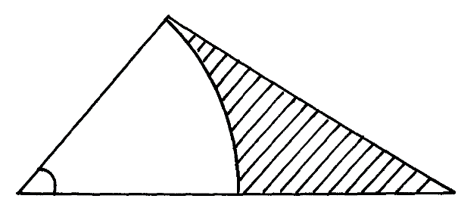
A
D
B
60º
7cm
7cm
5cm
C
Calculate (3 d.p)
a) The area of triangle ADB (2mks)

.
b) The area of the shaded region. (2mks

11. If cos A = and A is obtuse, find without using tables or calculators
a) Sin A (2mks)

b) Tan A (1mk)

12. A matatu left town X at 9.37a.m. towards town Y at an average speed of 78km/h. At 9.47a.m. a
Car left the same venue at an average speed of 84.5km/h. Determine the time when
The car caught up with the matatu . (3mks)

13 Using a set square, a ruler and a pair of compasses, divide the given line into five equal parts. Measure the length of one part. (3 marks)

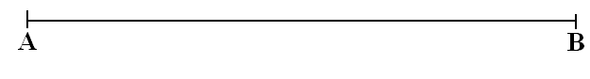

14. Simplify the expression. x² + 14x + 49 (3mks)

x² - 49

15. The acceleration of a particle in ms⁻² is given by the expression Acc=3t –4
Given that t=0 sec V=3m/s and S=0 metres
Find:
(i) an expression for velocity Vms-¹ (2 mark)

(ii) An expression for distance S metres from a fixed point O. (2 marks)

16. A salesman earns a basic salary of Kshs.19, 000 per month. In addition, he earns a commission of 5% for all sales above ksh.20,000. In February 2023, he sold goods worth 115,000. Calculate his total earnings that month . (3mks)

SECTION II (50 MARKS)
Answer only five questions
17. A triangle with A(-4, 2), B(-6, 6) and C(-6, 2) is enlarged by a scale factor -1 and centre
(-2, 6) to produce triangle A¹ B¹ C¹. Triangle A¹ B¹ C¹ is then reflected in the line
y = x to give triangle A¹¹ B¹¹ C¹¹
a) Draw triangle ABC, A¹ B¹ C¹ and A¹¹ B¹¹ C¹¹ and state the co-ordinates of
A¹ B¹ C¹ and A¹¹ B¹¹ C¹¹ (6mks)
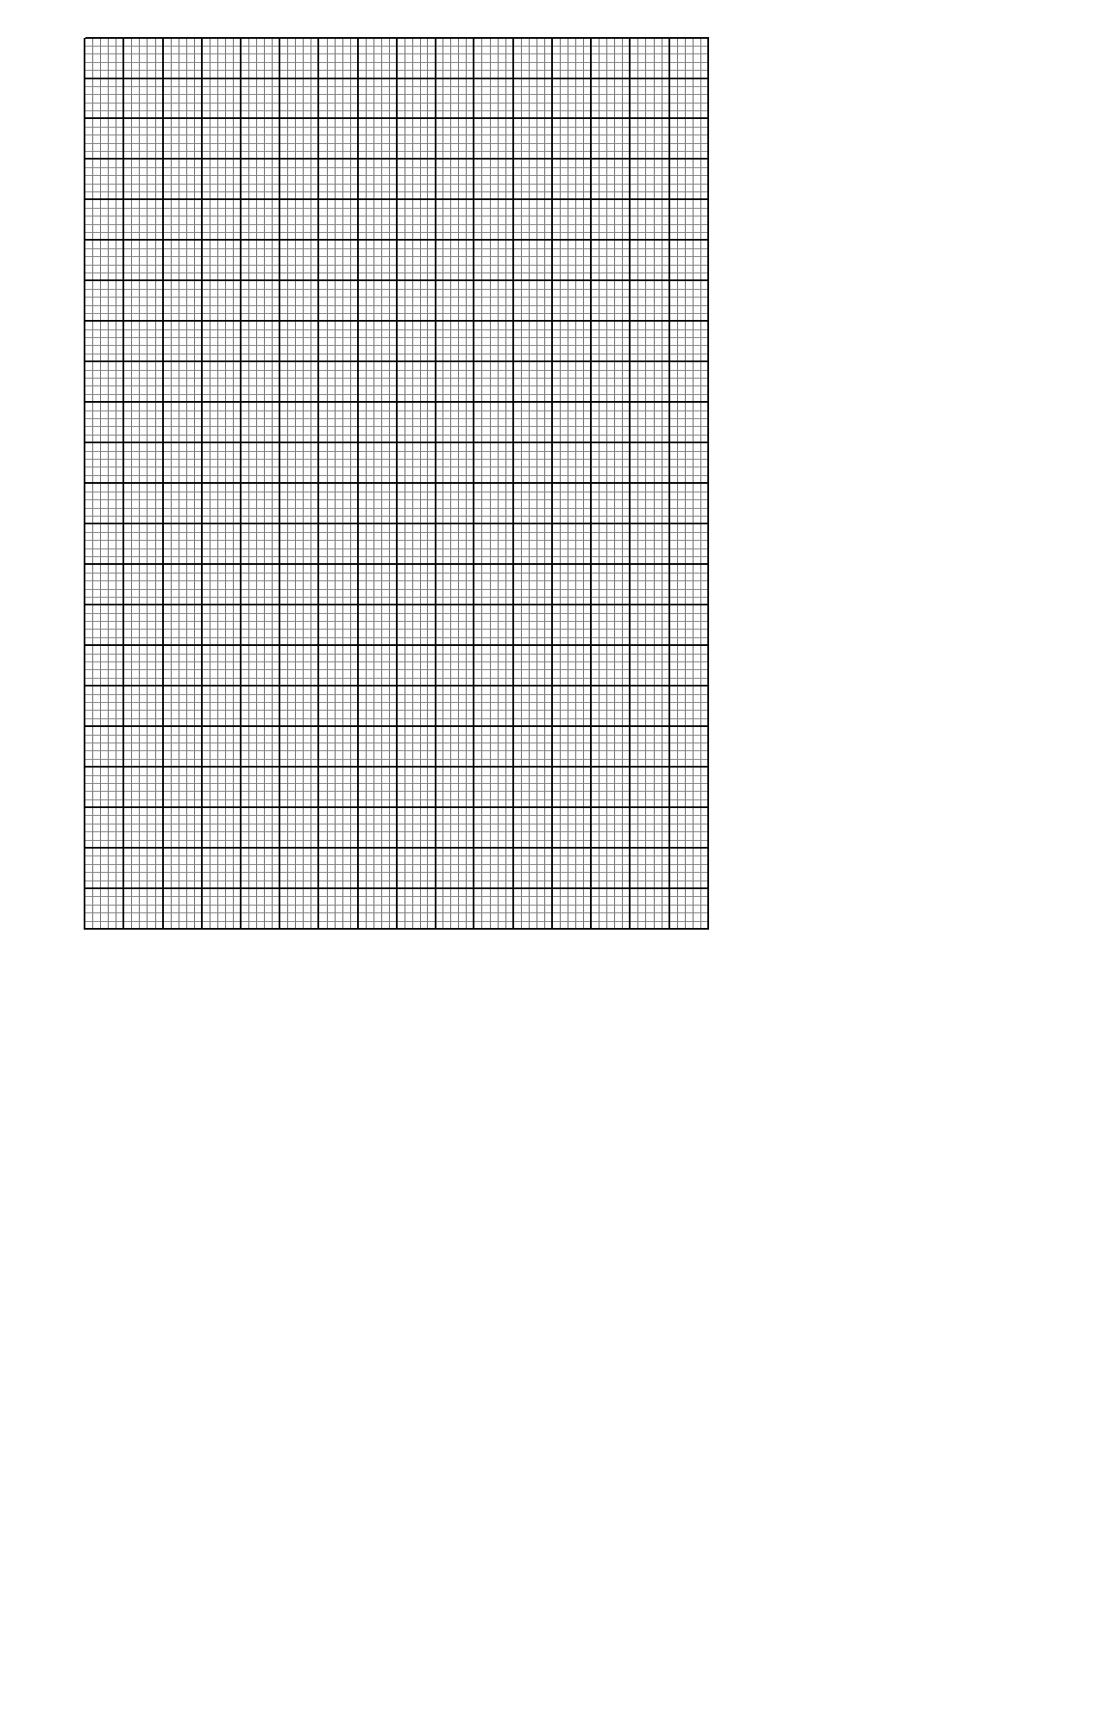

b) If triangle A¹¹ B¹¹ C¹¹ is mapped onto A¹¹¹ B¹¹¹ C¹¹¹ whose co-ordinates are A¹¹¹(0, -2), B¹¹¹(4, -4) and C¹¹¹ (0, -4) by a rotation. Find the centre and angle of rotation (4mks)

18. A cylindrical water tank of diameter 5m and height 1.8m is supplied with water by pipe P of
internal radius 2.5cm. Water flows through this pipe at the rate of 50m per minute. A drainage
pipe Q can empty the full tank in 8 hours.
a) Calculate the time in hours that pipe P alone would take to fill the empty tank (4mks)

b) The tank is initially half full. Water flows through pipe P into the tank for 2 hours.
The drainage pipe Q is then opened and both pipes left running.
Determine how long it will take to fill the tank (6 mks)

19. Ken and Jane cycle to school 20km away. Jane cycles at 2km/h faster than Ken and reaches there half an hour earlier. Given that the speed of Ken is xkm/hr. Find in terms of x
a). The time taken by Ken. (1 mk)

b) The time taken by Jane. (1 mk)

c) Form an equation in x. (1 mk)

d) Solve the equation in (a) above and find the speed of Ken and Jane. (7 mks)

20. The table below shows some paired values of X and Y for a known curve.
X | 0.0 | 0.2 | 0.4 | 0.6 | 0.8 | 1.0
Y | 0.0 | 0.4 | 1.6 | 3.6 | 6.4 | 10.0
By establishing how x and y relates.
Estimate the area under the curve for the interval 0 < X< 1 using
a).The mid – ordinate rule with five mid – ordinates. (4mks)

b).The trapezium rule with five Trapezia. (2mks)

c) If the exact area is ¹⁰/₃ square units.
Calculate the percentage error in the two estimates. (4mks)

21 The following are speeds in m/s of the first 50 vehicles at a police check point.
Speed  in m/s  x | No. of  vehicles  f f(x)
10 - 19  20 – 29  30 - 39  40 - 49  50 - 59  60- 69  70 – 79  80 - 89  90- 99  100 -109 | 3  1  2  5  6  11  9  8  3  2

a) Calculate the mean speed (4mks)

b) Draw on the same axes using this information
i) The Histogram (3 mks)

ii)The Frequency polygon (1 mk)

c) Calculate the median speed. (2mks)

22. A trader sold an article at sh.4800 after allowing his customer a 12% discount on the marked price of the article. In so doing he made a profit of 45%.
- Calculate
  - The marked price of the article. (2 marks)

  - The price at which the trader had bought the article (2 mks)

- If the trader had sold the same article without giving a discount. Calculate the percentage profit he would have made. (3 mks)

- To clear his stock, the trader decided to sell the remaining articles at a loss of 12.5%. Calculate the price at which he sold each article. (3 mks)

.

23. The diagram below shows a parallelogram OPQR. Point M divides line PQ in the ration 2:3
PR and OM intersect at N. Given that
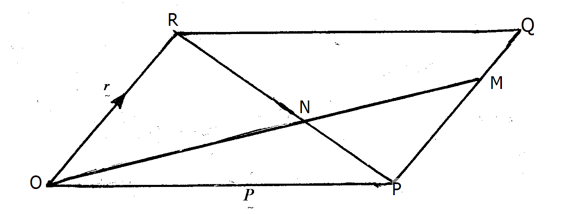
a) Express the following vectors in terms of and
i) (1mk)
ii) (1mk)
b) Given that = and = +

By Expressing ON in two different ways find the ratio in which N divides PR. (8 mks)

24. The diagram below shows the graph of a moving matatu from Nakuru to Naivasha.
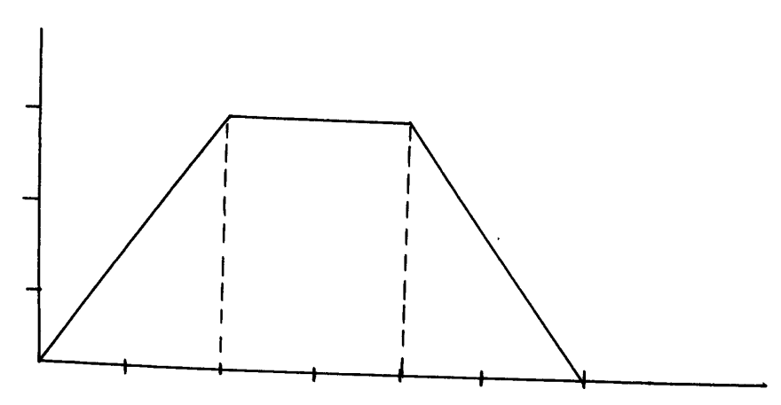
Velocity
m/s
15

10

5
Time in sec
10 20 30 40 50 60
a) Find the acceleration of the matatu. (2mks)

b) Find the deceleration of the matatu (2mks)

c) Calculate the distance the matatu travelled while accelerating. (2mks)

d) Calculate the distance the matatu covered while traveling at an acceleration of 0m/s² (2mks)

e) Find the distance between the two Towns. (2 mks)

